First, start with a breadboard 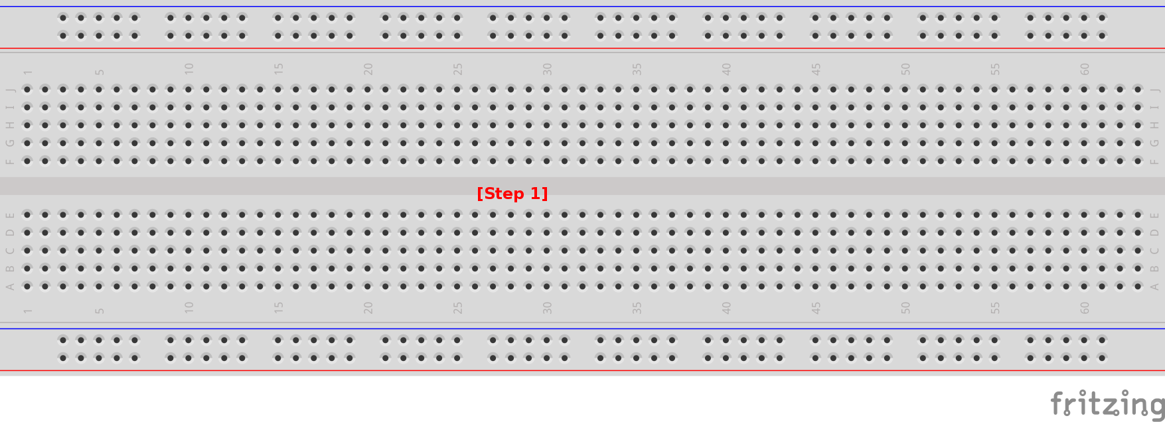[Step 1]. This is an object that helps prototype electrical projects by allowing electrical connections to form without having to solder anything.

Connect the two sides of the breadboard 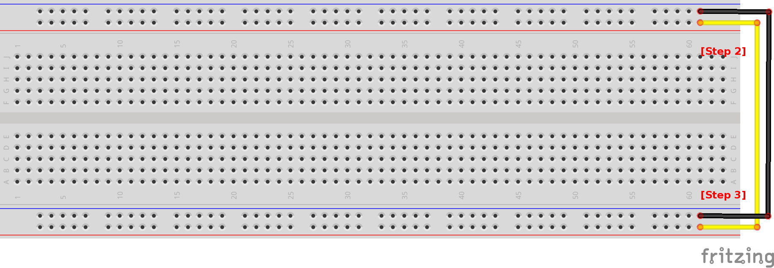with male-to-male wires [Step 2 & 3]. The row of holes nearest the blue line (some boards have a minus sign) is ground and the side nearest the red line (plus sign) is voltage. The color of the wires doesn't matter but pay attention to where the wires connect.

Place the amplifier on the breadboard straddling the gap 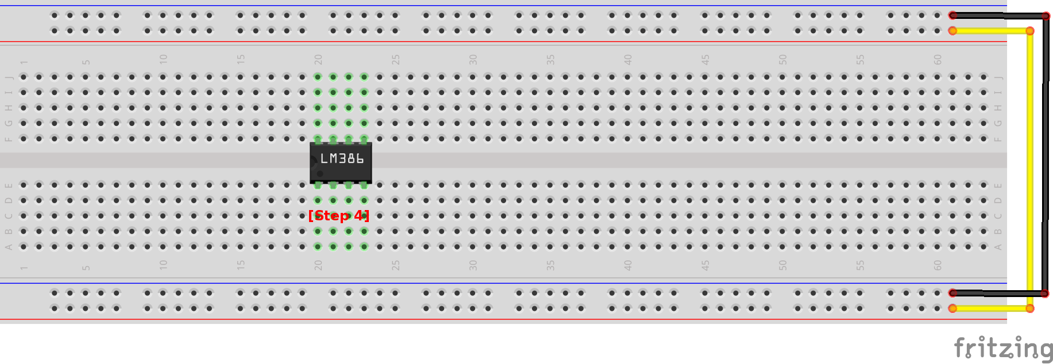[Step 4]. It is important to note which direction the notch on the chip is facing as the pins of the amplifier are numbered 1 – 8 starting on the bottom left side in this orientation. A diagram of the LM386 amplifier can be found in the appendix. Be careful not to touch the amplifier with your fingers as it is a sensitive electronic. Use pliers instead.

Connect a 1.2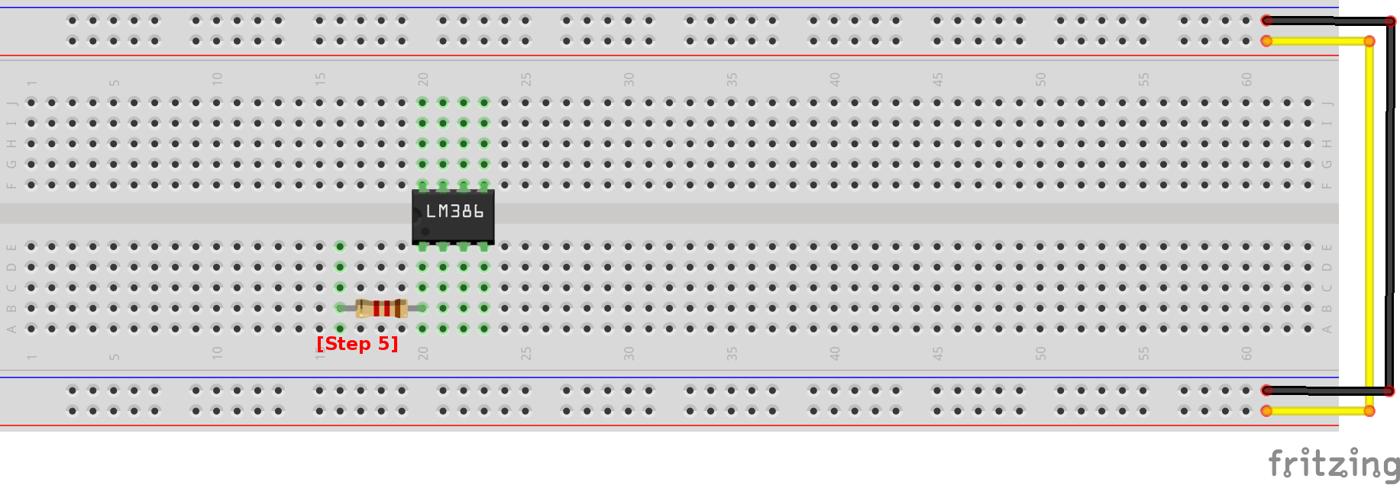K ohm, ¼ watt resistor to pin 1 of the amplifier [Step 5]. In this schematic, the color of the resistors are not necessarily the correct color so be sure to check the label they came with or check using a multimeter.

Add a 10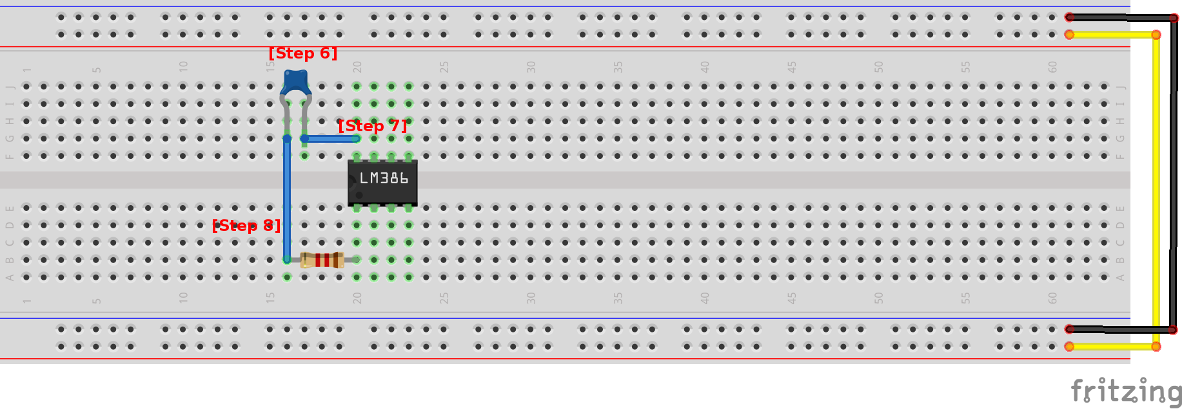μF ceramic capacitor [Step 6] to the breadboard and connect it to both pin 8 of the amplifier and the resistor [Step 7 & 8].

Connect pins 2 and 4 of the amplifier to 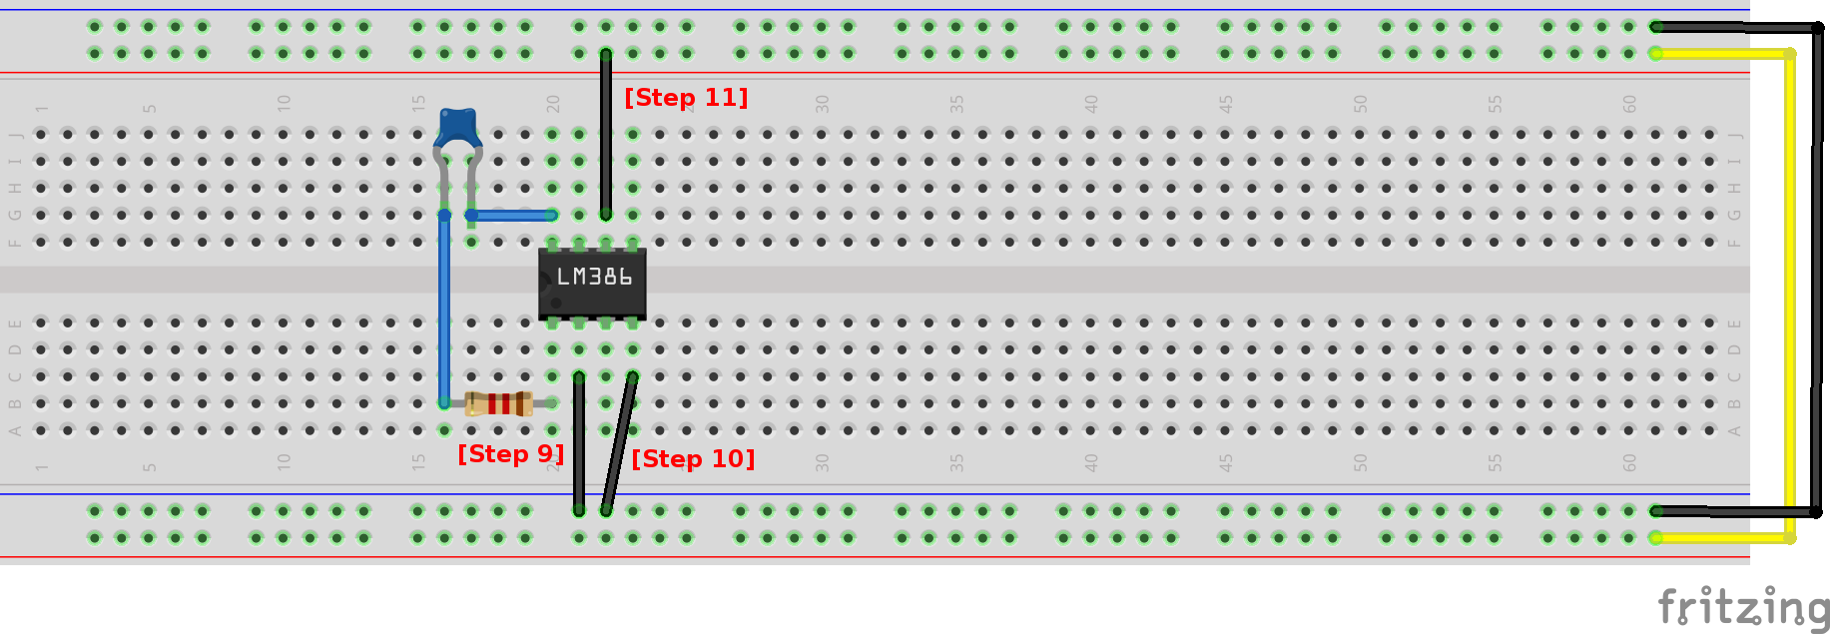ground [Step 9 & 10] and pin 6 to voltage [Step 11].

Give yourself some working space by connecting pin 3 of the amplifier 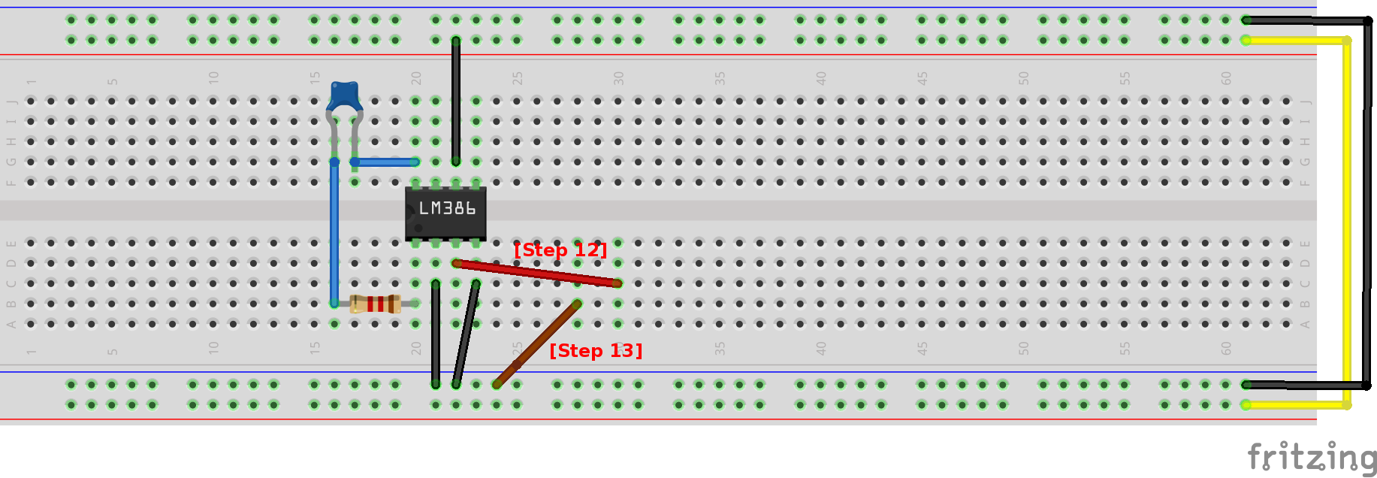to another place on the breadboard [Step 12] and do the same for ground [Step 13].

Add a 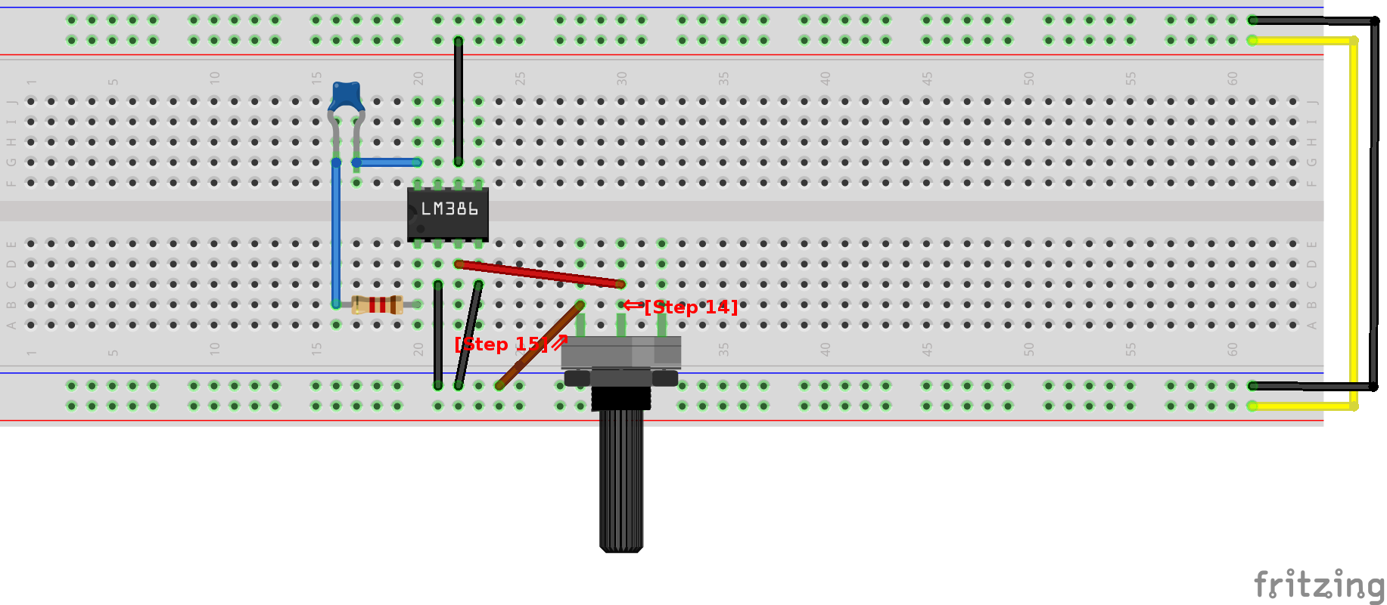10k ohm potentiometer. The potentiometer has 3 leads. The middle lead should be connected to the wire that connects to pin 3 of the amplifier [Step 14] and one of the others to the lead from ground [Step 15].

Connect the remaining lead of the potentiometer as shown 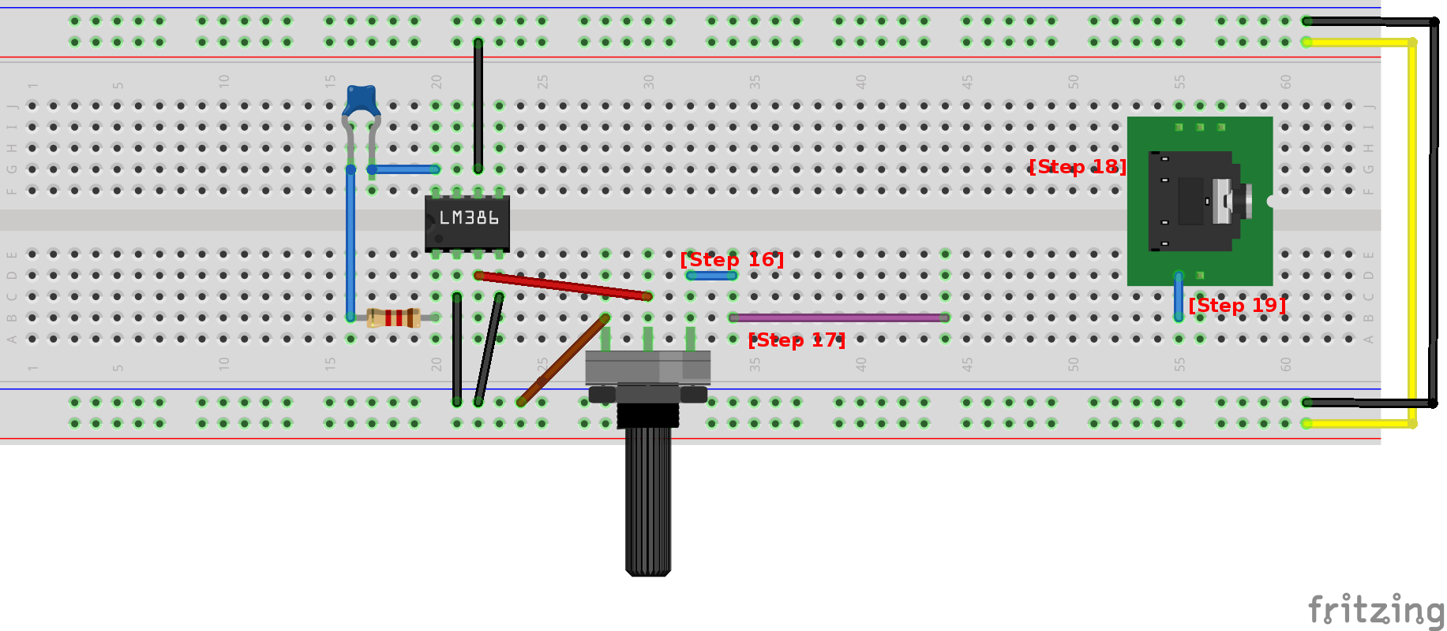[Step 16 & 17] and add the breadboard-friendly audio jack [Step 18]. Sometimes the jacks have different configurations so check with the manufacturer. For our purposes, extend the reach of pin 4 of the jack with a small amount of wire [Step 19].

Connect pin 5 of the amplifier to a 10 ohm resistor 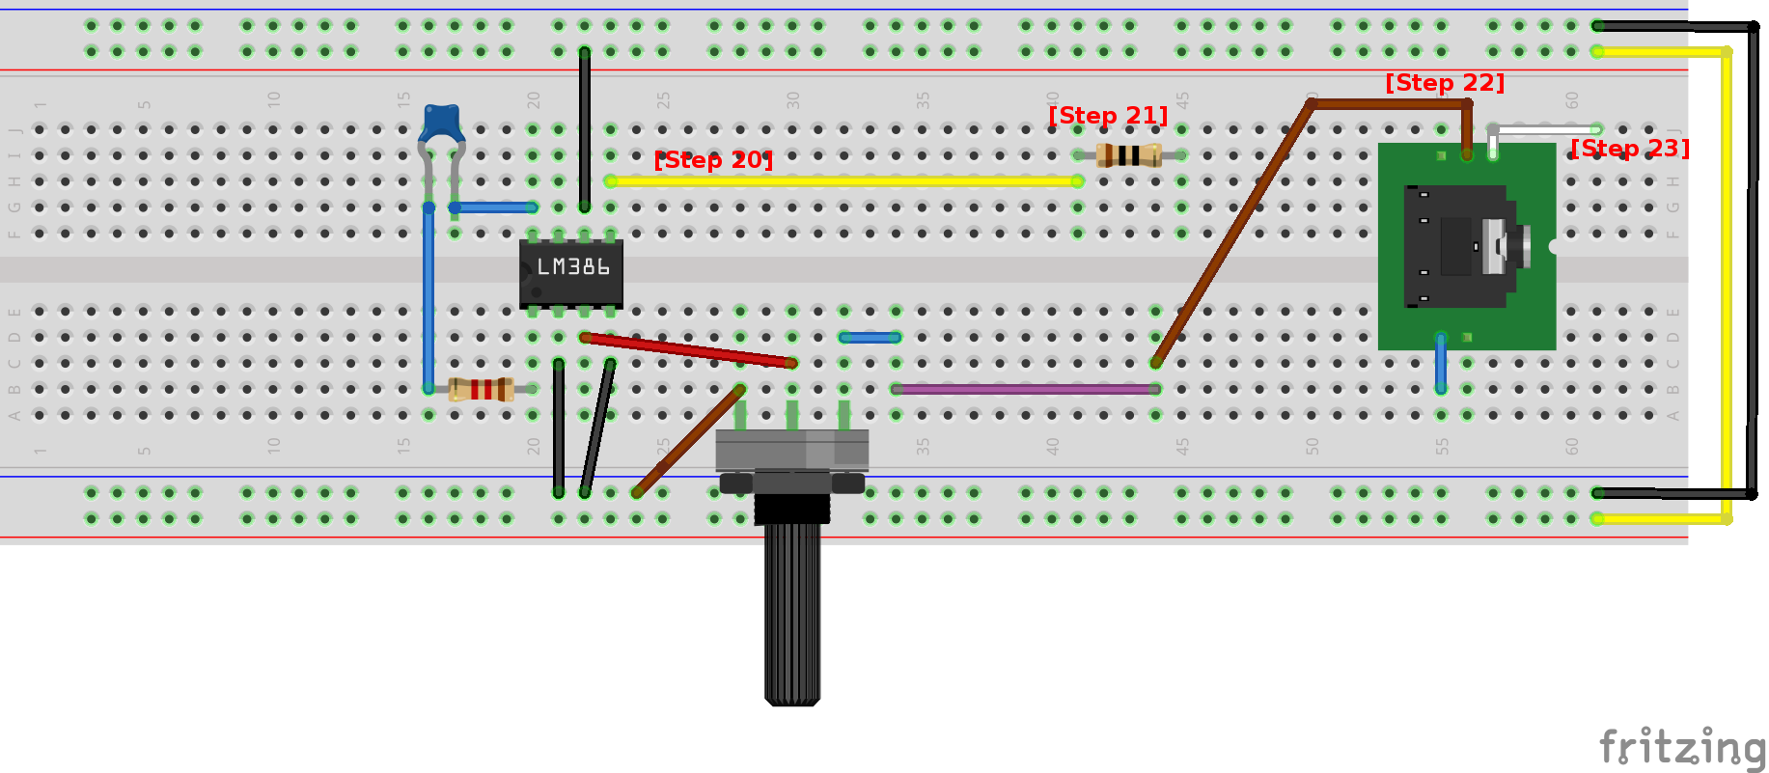[Step 20 & 21] and connect pin 2 of the jack to the last lead on the potentiometer [Step 22]. Extend pin 1 of the jack out a bit [Step 23].

Add a 250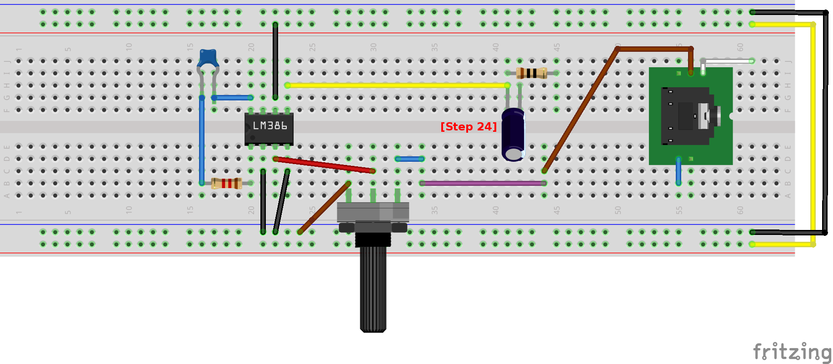μF electrolytic capacitor just on the other side of the wire coming from pin 5 of the amplifier [Step 24]. Electrolytic capacitors have a polarity meaning they need to face a particular direction. Place the pin on the side with the white minus marking furthest from the wire coming from pin 5 of the amplifier.

Add a 0.05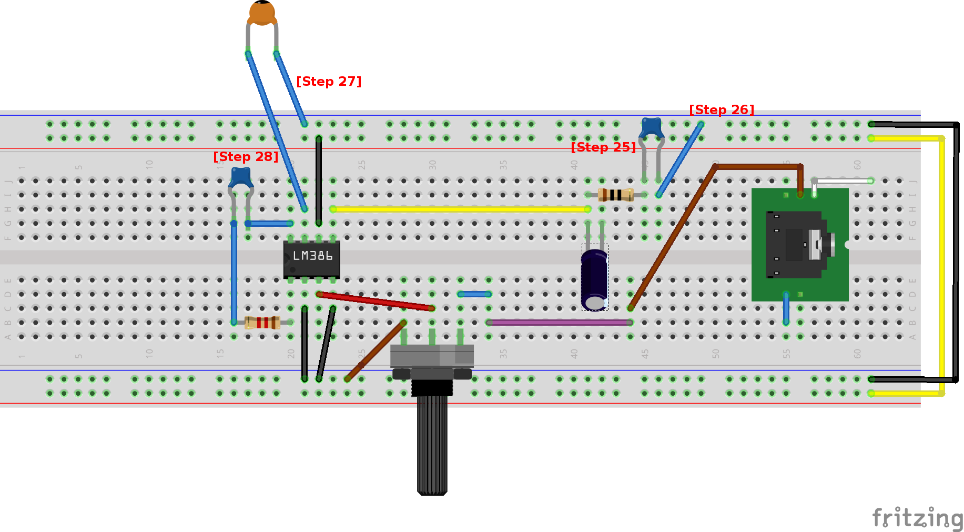μF ceramic capacitor on the other end of the resistor [Step 25]. Connect the remaining lead of the ceramic capacitor to ground [Step 26] and then add a ceramic capacitor that is connected to both ground [Step 27] and pin 7 of the amplifier [Step 28].

Connect an 8 ohm speaker to both ground 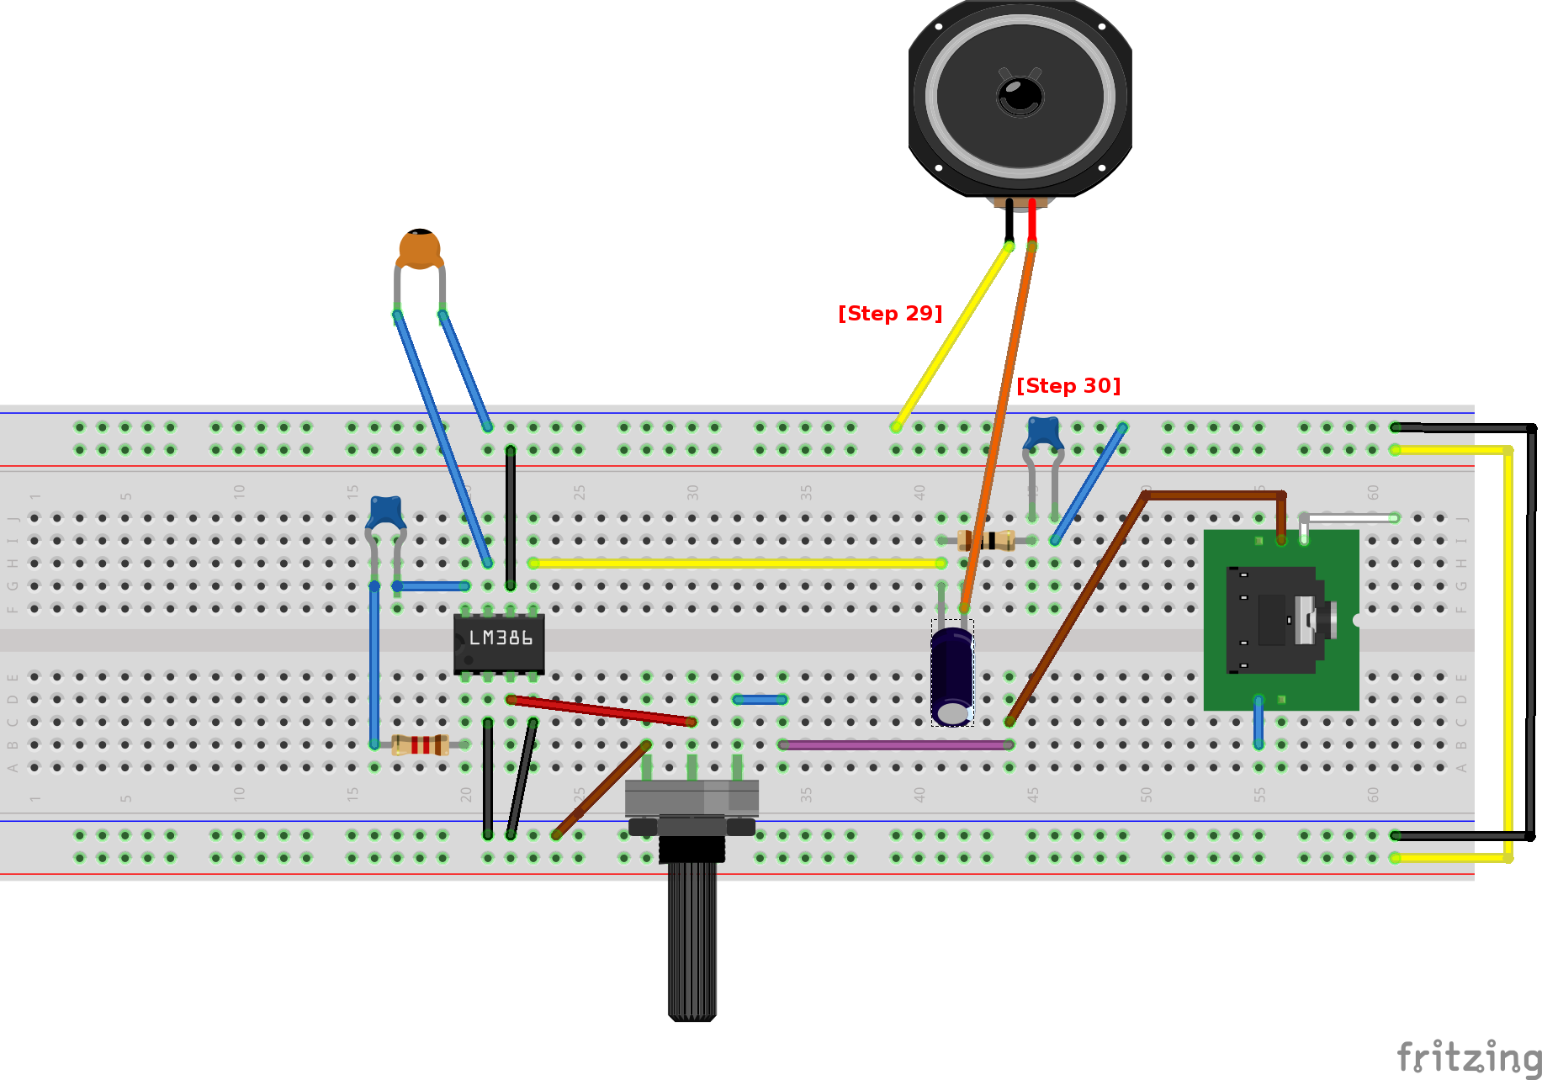[Step 29] and the output of the electrolytic capacitor [Step 30].

We're ready to start working on the second breadboard 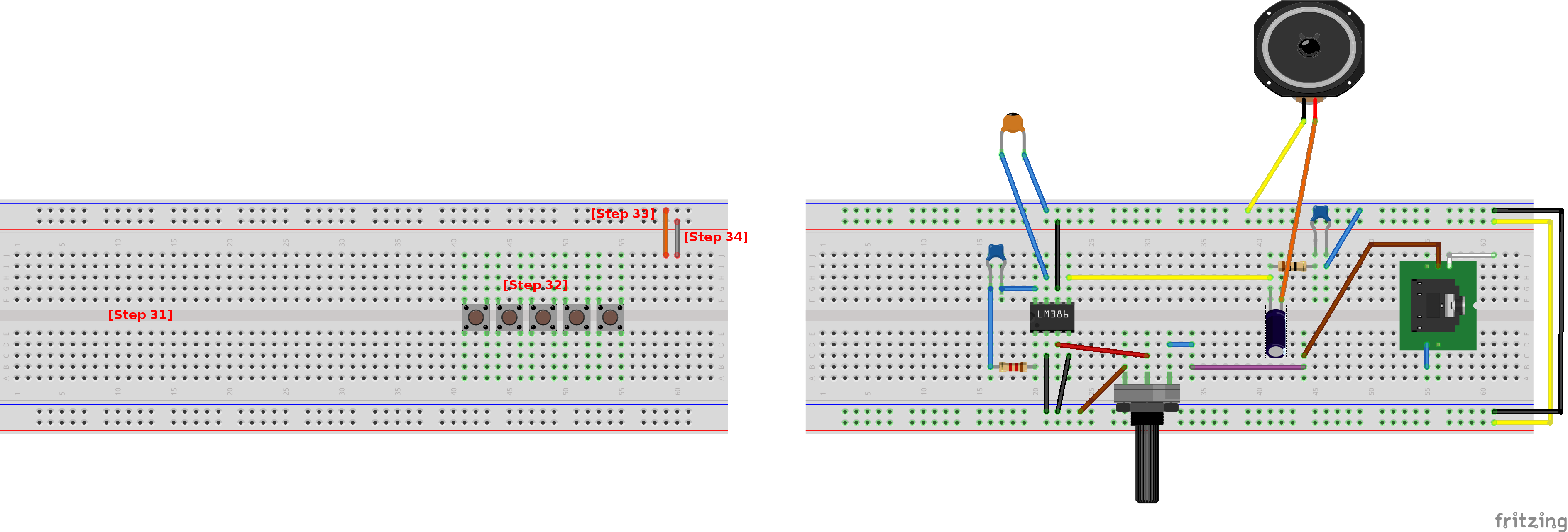[Step 31]. Attach 5 push buttons so that they straddle the gap in the breadboard [Step 32] and connect a column of the breadboard to ground [Step 33] and a column to voltage [Step 34].

Add 5 1.5K ohm resistors to the rightmost pin of each push button and ground [Step 35]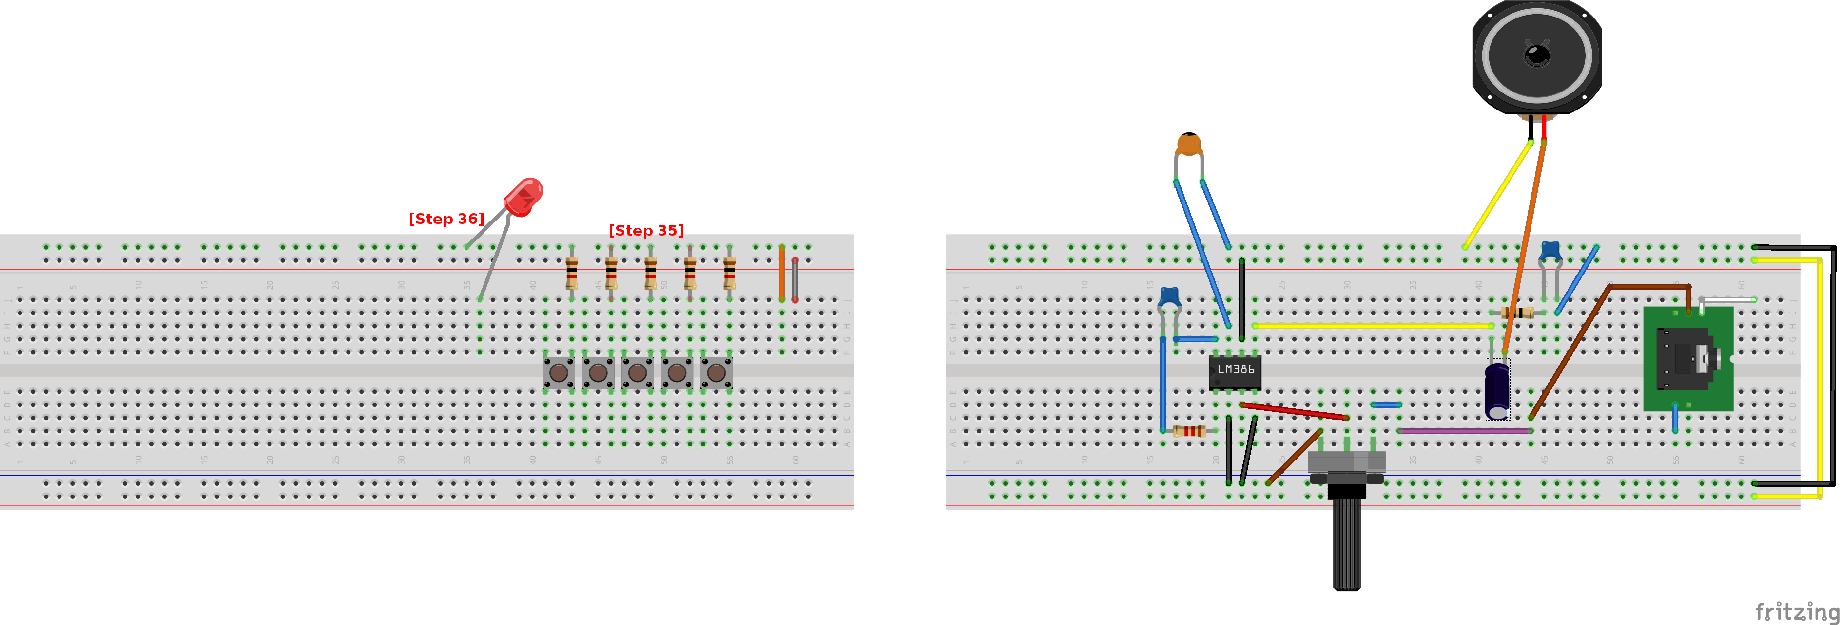. Connect an LED from ground to the breadboard as well [Step 36]. LEDs have a polarity so be sure to connect the short lead to ground and the longer lead to a position on the breadboard.

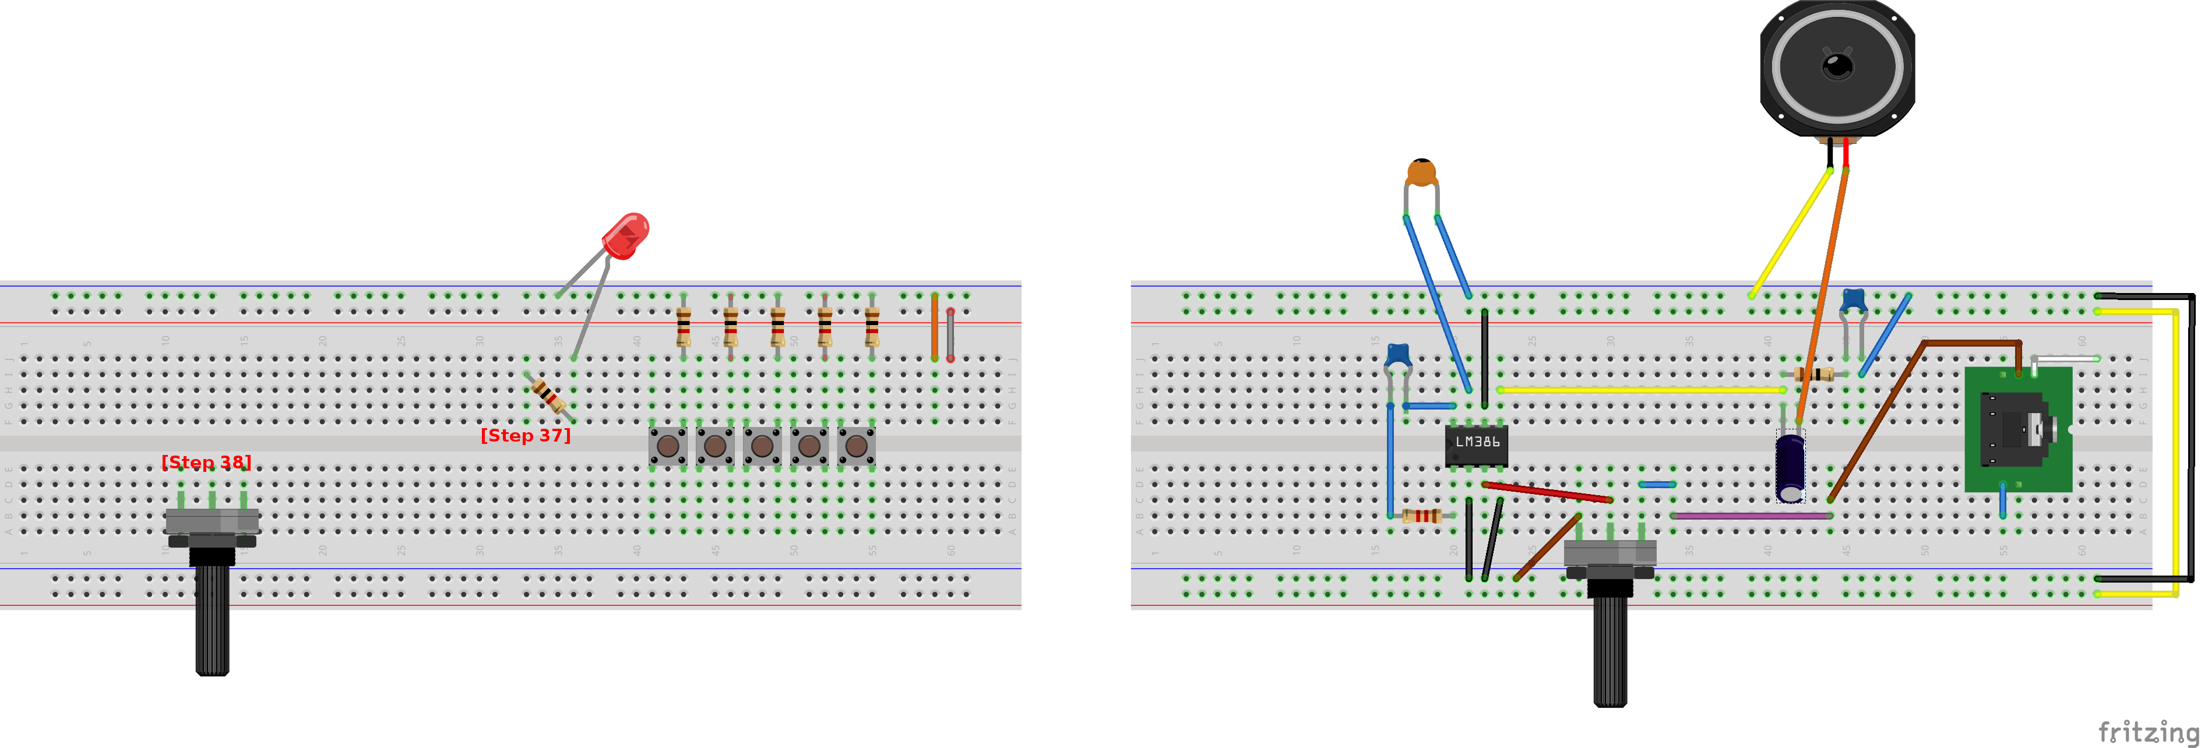Add a 1k ohm resistor to the same column as the LED's long lead [Step 37] and a 10K ohm potentiometer [Step 38] to a free area on the breadboard.

Connect one of the outer leads of the potentiometer to voltage 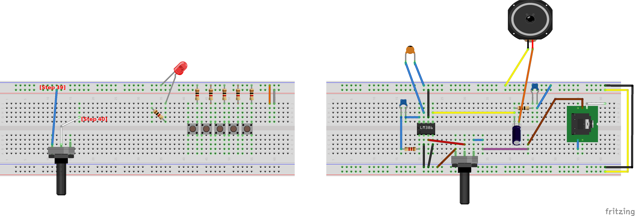[Step 39] and the middle lead to a free position on the breadboard [Step 40].

Connect the remaining potentiometer lead to ground 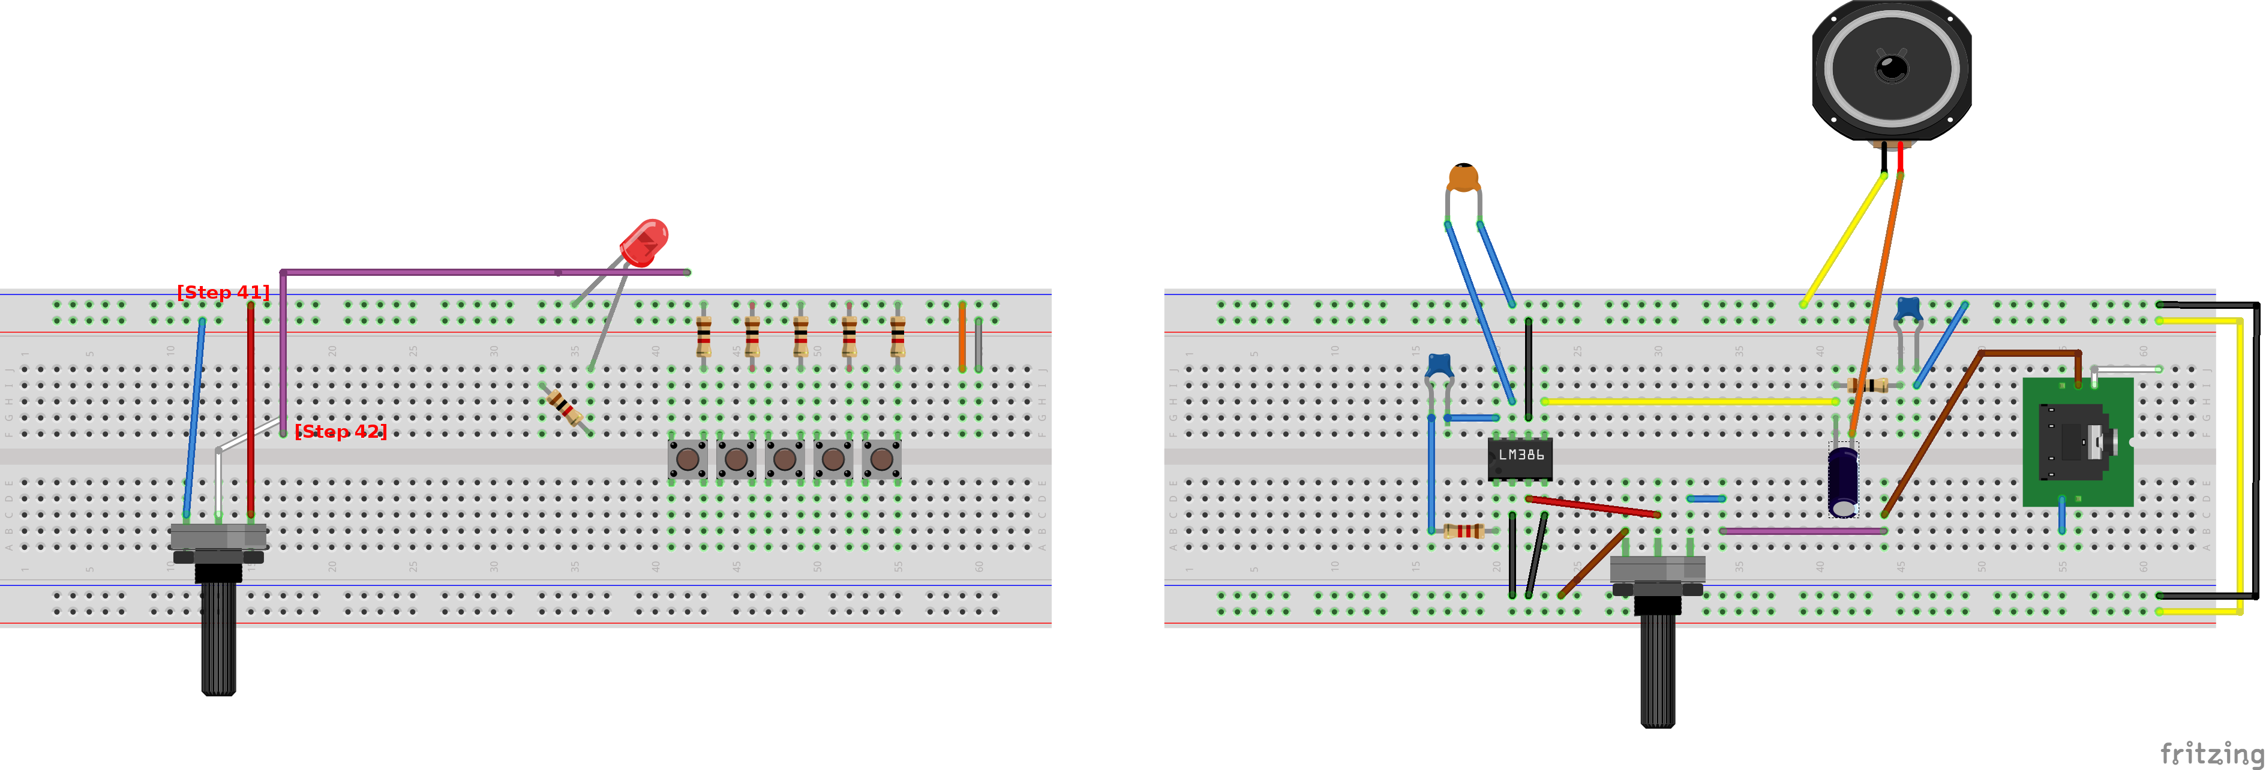[Step 41] and extend the wire from the middle lead off to the side for now [Step 42].

Add wires to ground 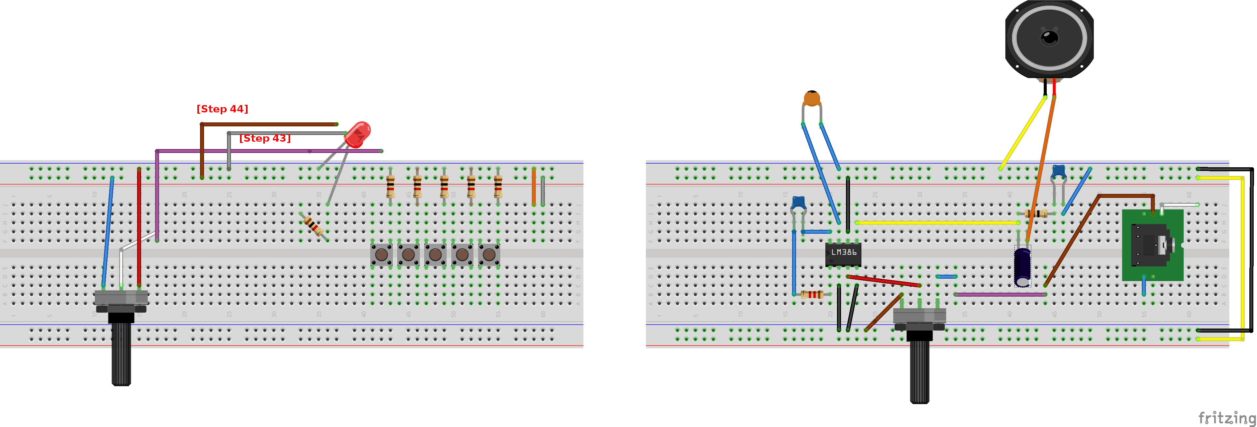[Step 43] and voltage [Step 44] and keep them disconnected for later.

Add wires to ground 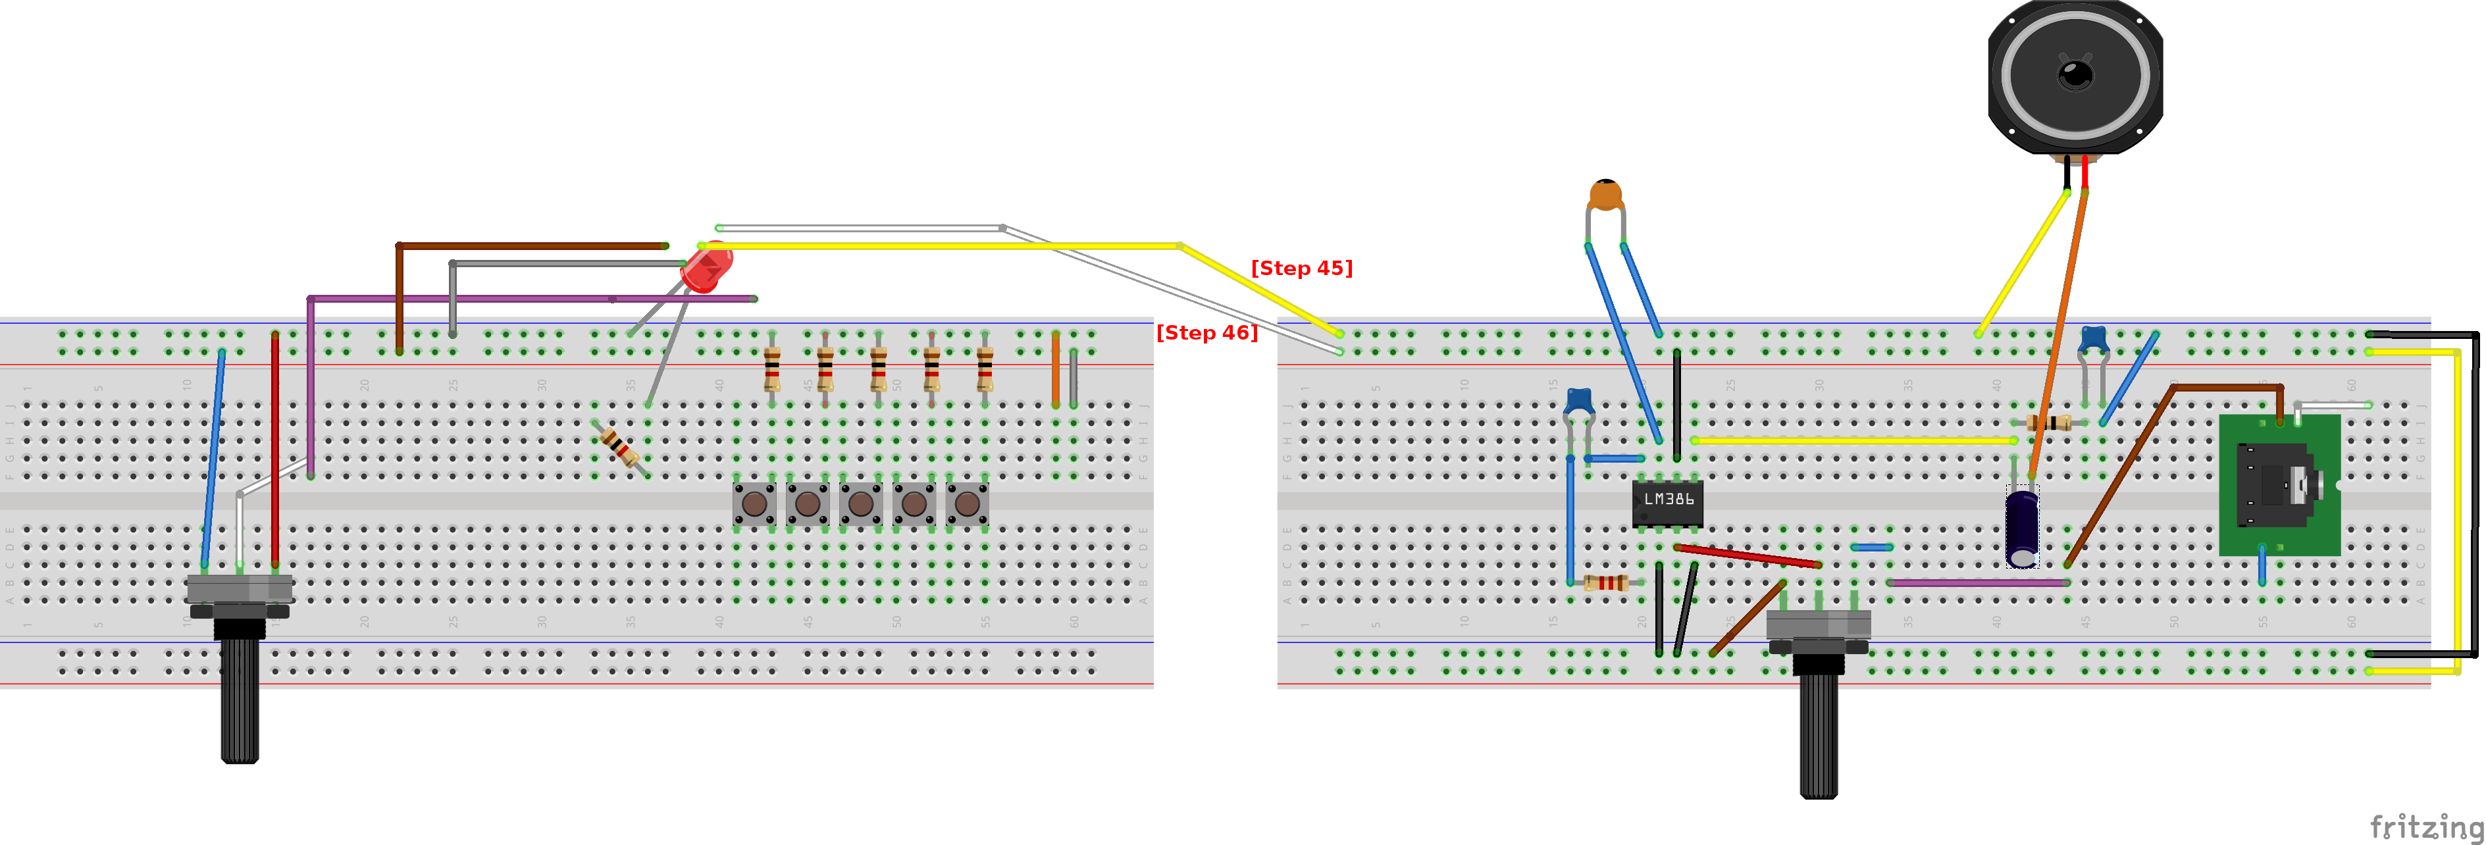[Step 45] and voltage [Step 46] on the other breadboard and keep them disconnected for later.

Add a wire to the end of the resistor 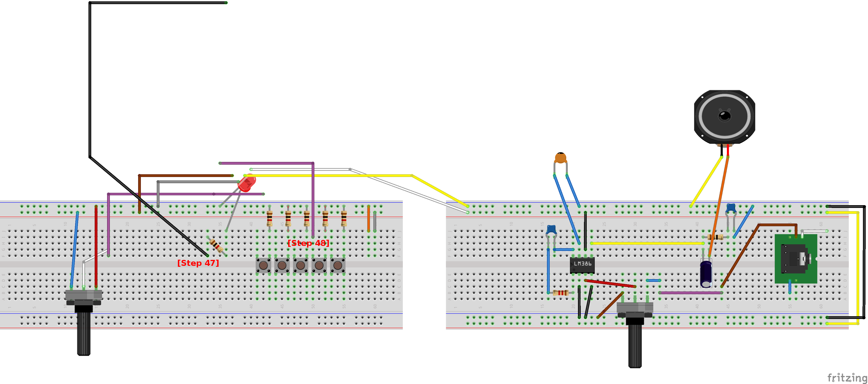[Step 47] and one to the left leads of the middle push button [Step 48].

Add wires to the left lead of the first 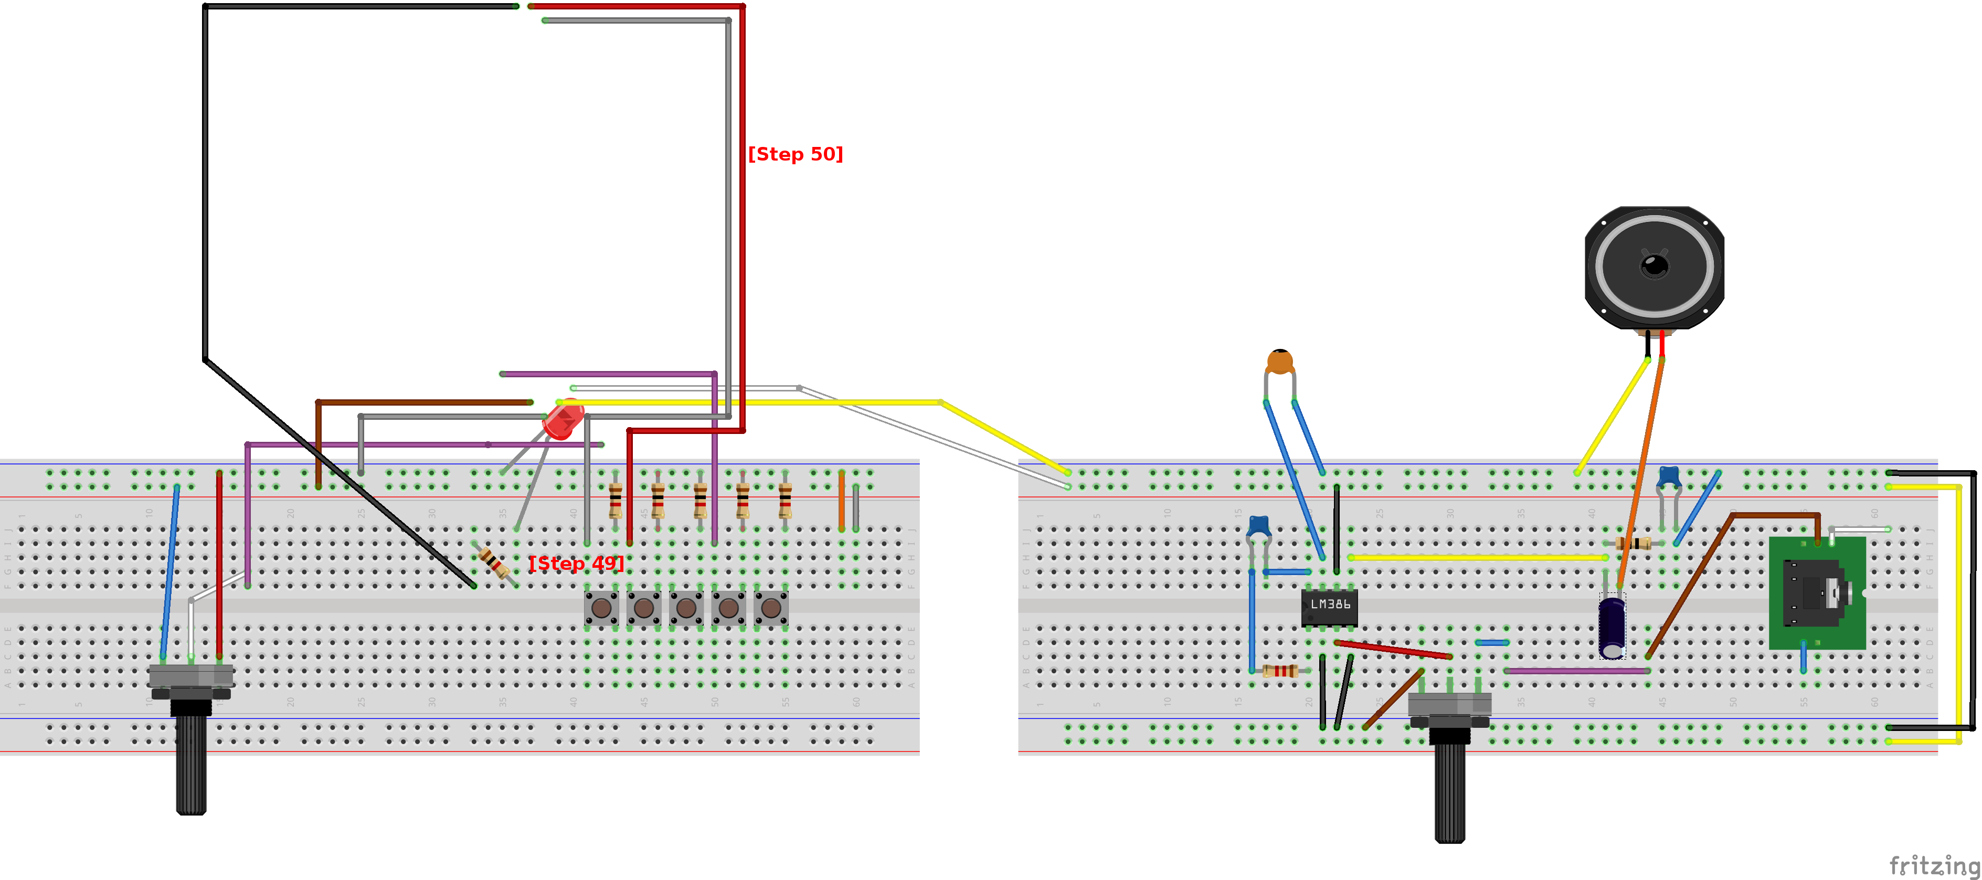[Step 49] and second push buttons [Step 50].

Add wires to the left leads of the remaining push buttons 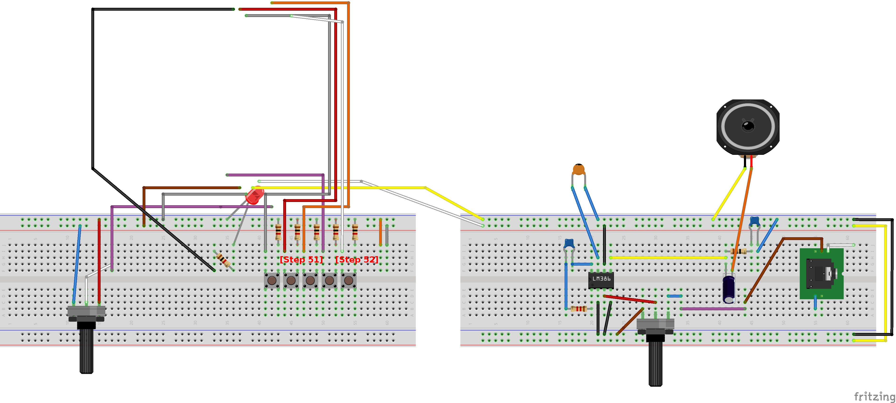[Steps 51 & 52].

Add an Adafruit 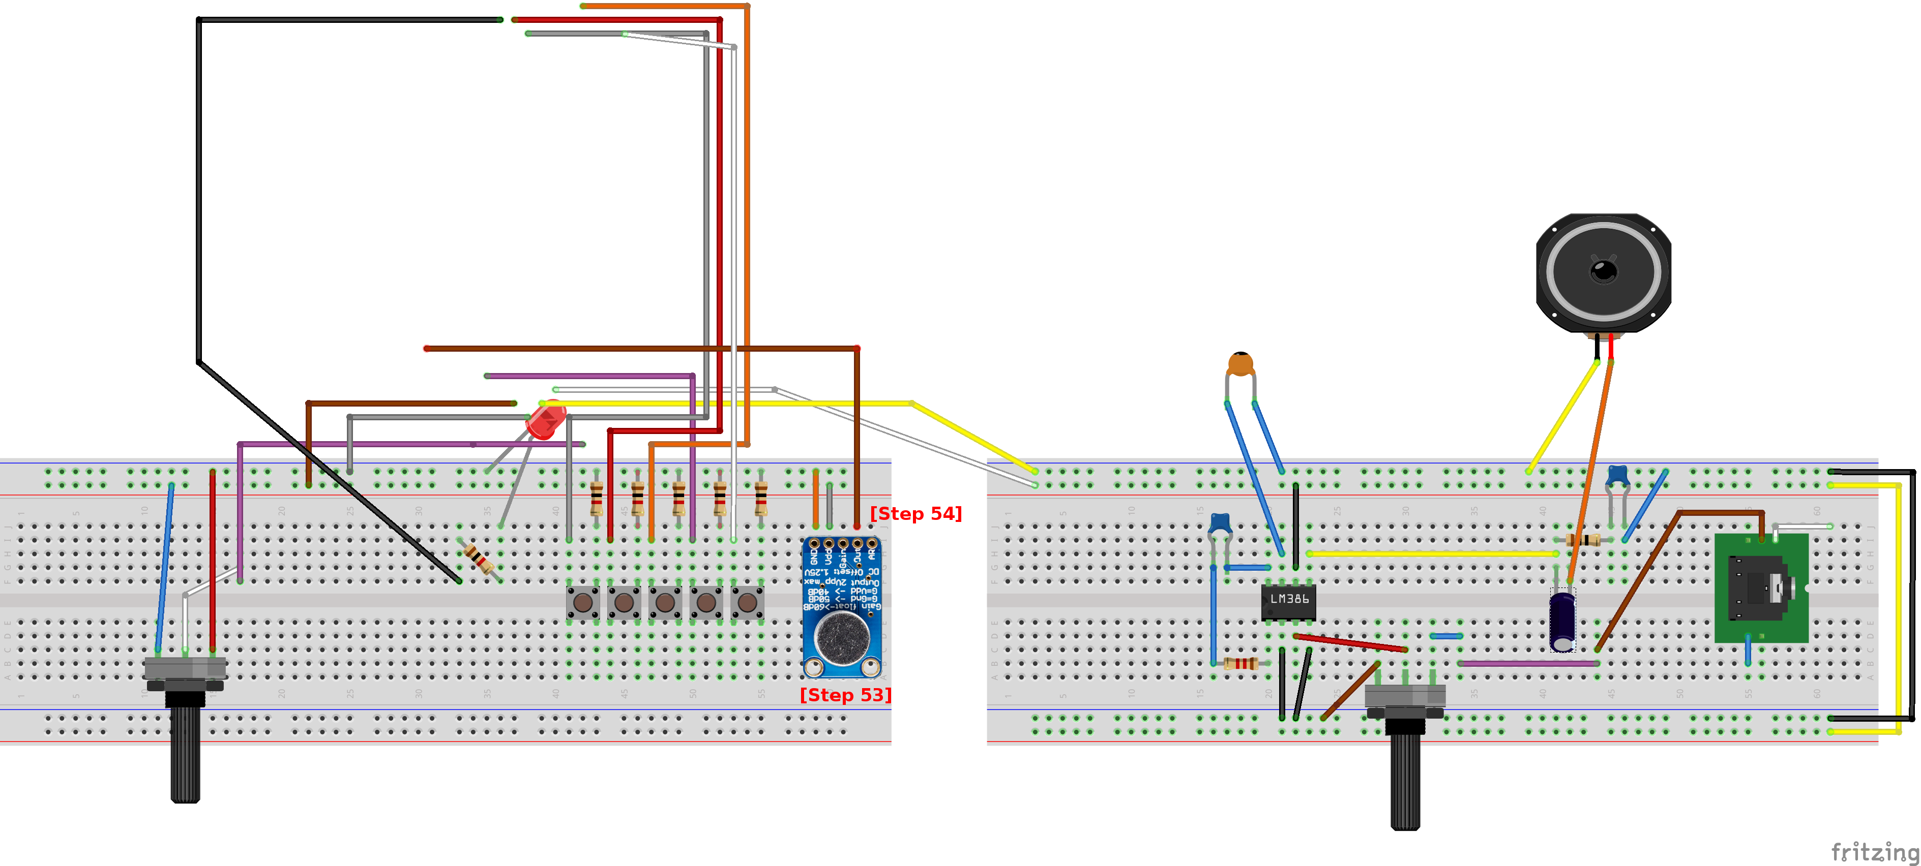Max 9814 microphone [Step 53] and add a wire from its lead marked “out” [Step 54].

Add an Arduino Uno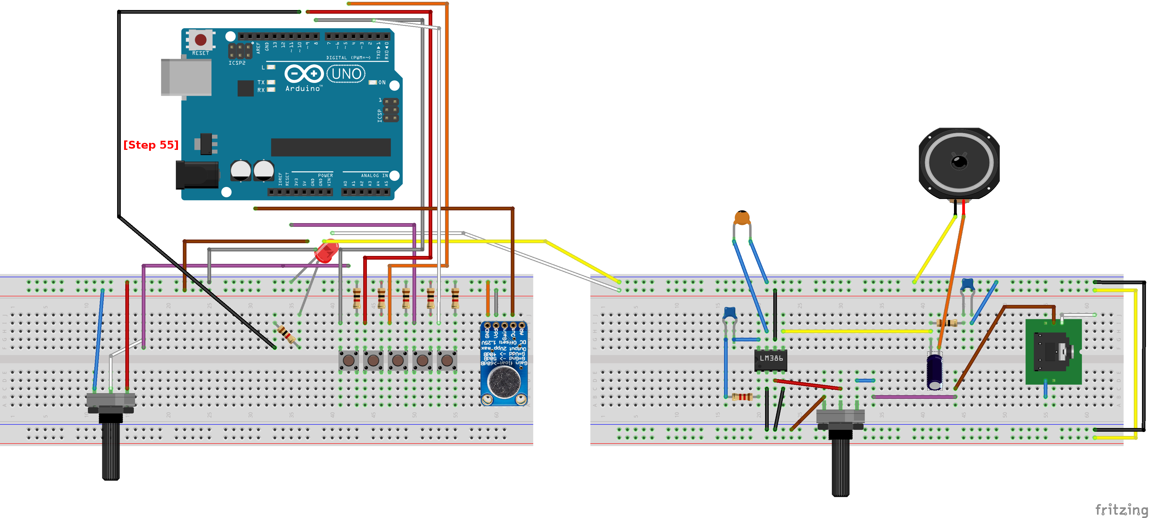[1][Step 55]. The Uno will serve as the “brains” of the audio device and contains the core logic of the audio program.

The Uno has several pins on top that line up with the lower pins of the Adafruit MusicMaker shield. 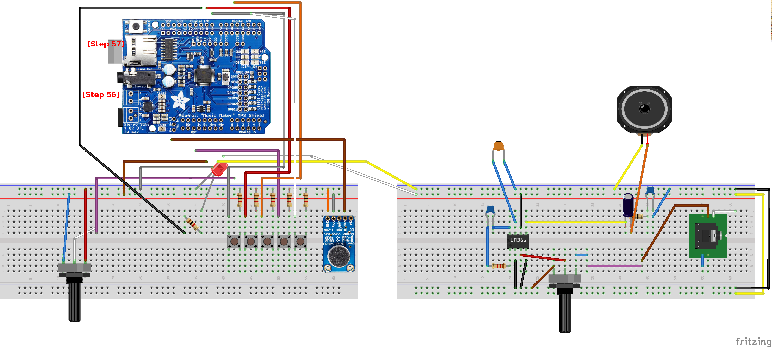Add the shield [Step 56] and Insert a micro SD card into the slot found on the MusicMaker shield [Step 57].

Connect the loose wires from earlier. 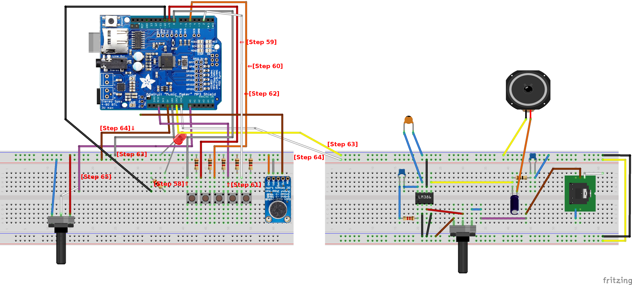The wires connect to the top of the MusicMaker shield. From left to right, the push buttons connect to digital pins 8 [Step 58], 9 [Step 59], 5 [Step 60], reset [Step 61], and digital pin 2 [Step 62]. Connect the leads from ground [Step 63] and voltage [Step 64] from both breadboards to the Uno's 5V, GND and VIN pins as shown. Lastly connect lead from the potentiometer to the Analog 0 position on the MusicMaker shield [Step 65].

Finally, connect the lead from the “out” on the microphone to the “M+” position on the MusicMaker shield 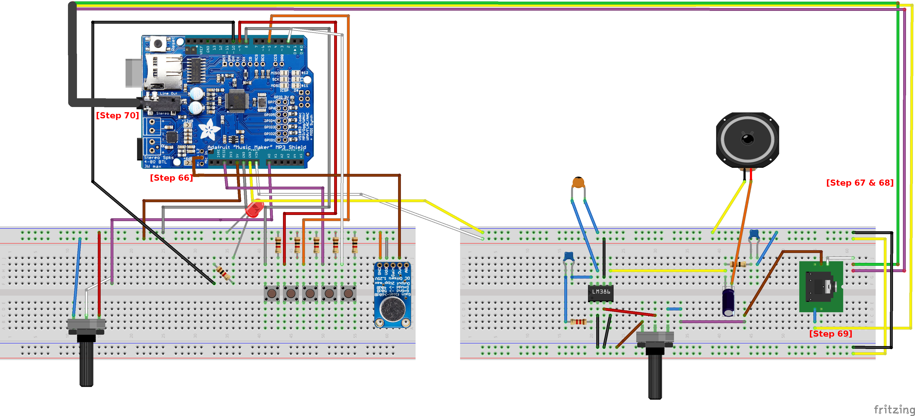[Step 66]. Going back to the audio jack, connect the wire from pin 1 to two wires (left & right stereo) [Step 67 & 68] and pin 5 to a third wire [Step 69]. These three wires connect to the audio jack on the MusicMaker shield [Step 70].

1. With some modifications, an Arduino Mega can also be used.